|  |  |  |  |
| --- | --- | --- | --- |
| .Provider | | | |
| DODD – Possible or Determined MUI Report Form | | | |
| Individual’s Name: | | DOB: | |
| Address: | | City/County: | |
| Date of Incident: Time of Incident: AM/PM | | | |
| Location of Incident (home in bathroom, at the mall, lunchroom at work): | | | |
| Description of Incident (Who, W hat, W here, W hen): | | | |
| Injury – Describe Type & Location: | | | |
| Immediate Action to Ensure Health & Welfare of Individuals: | | | |
| Name of PPI(s): | Relationship to Individual: | | |
| Witnesses to Incident: | Others Involved: | | |
| Type of Notification | Name/Title | | Date/Time |
| Guardian / Advocate |  | |  |
| SSA (required for Independent Providers0 |  | |  |
| Licensed or Certified Provider |  | |  |
| Staff or Family living at the Individual’s home & responsible for the individual’s care. |  | |  |
| LE (Name, Badge Number, Jurisdiction, and contact information required for Law Enforcement |  | |  |
| CSB (Name and contact information required for Children Services) |  | |  |
| County Board |  | |  |
| Administrator (Required for ICF) |  | |  |
| Support Broker (If applicable) |  | |  |

|  |
| --- |
| Additional Information/or Administrative Follow-Up:  A. Further Medical Follow-up: |
| B. Administrative Action: |
| Signature: Title: Date: |

Body Part Injured:

|  |  |  |  |
| --- | --- | --- | --- |
| 0 | Head or Face | 0 | Neck or Chest |
| 0 | Mouth / Teeth | 0 | Abdomen |
| 0 | Hands / Arms | 0 | Back / Buttocks |
| 0 | Feet / Legs | 0 | Genitals |

0 Other

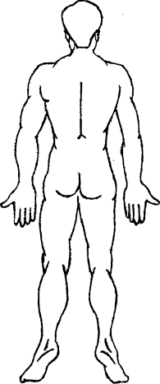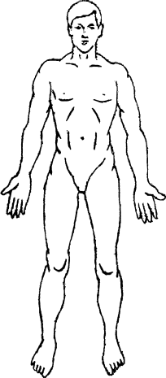



Causes and Contributing Factors:

Preventive measures: (For Provider’s internal use)

Administrator Review:

Title _ Date: