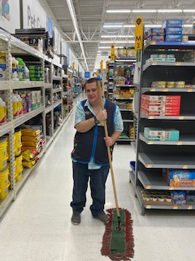    Employment First  - Every person has abilities, skills and talents to enrich the community and people around us. We envision a time when every working-age adult with developmental disabilities has opportunity to explore their career options and seek jobs that fit their skills and interests.  - Every person should expect that community employment is the preferred outcome for working-age adults with developmental disabilities.
  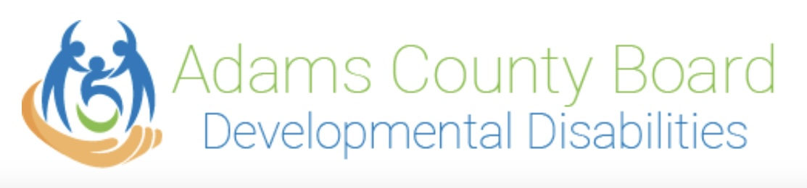
  About Us
  The Adams County Board of Developmental Disabilities (ACBDD) believes that all persons with developmental disabilities have a right to be fully included in the community in which they live. It is the Board's belief that each enrollee should be assisted to develop physically, emotionally, socially, and mentally to his/her fullest potential. This will enable each person to take his or her rightful place in the community. It is also the board’s intent to have services provided in such a way as to protect the rights, enhance the dignity, and promote the growth of each person served.
  Contact Us
  Phone: 937-544-2574
  Email: l.lafferty@adamscbdd.org
  Web: www.adamscbdd.org FB : Adams County Board of DD
  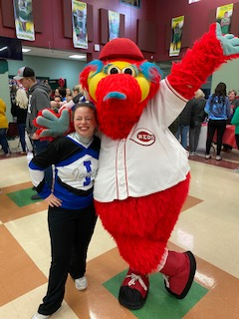
  Adams County Board of Developmental
  disabilities
  Community Inclusion
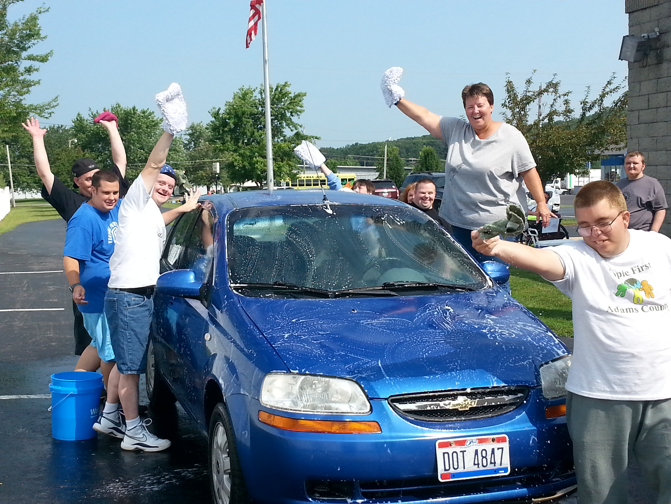People First of Adams County  Self-Advocacy  Opportunities  People First of Adams County Local group that focuses on community projects, disability awareness and self-advocacy activities. 937-544-2823  Southern Ohio Advocacy Group SOCOG – Monthly Zoom Meetings 740-273-1219  Project Stir – Ohio Self Determination Association and Ohio Developmental Disabilities Council Training Opportunities to become Self-Advocates and New Ohio Leaders www.osdaohio.org  COOL – Council of Ohio Leaders Serving as the advisory council to OSDA. | Advocacy is defined as public support for a particular cause or policy. You can practice advocacy simply by speaking up for yourself or others.  “People are self-determined when they use their ability or power to make choices and decisions based on their own preferences and interests to self-direct their lives.”  Self-Advocacy is……….. Speaking up for yourself  Asking for what you need  Negotiating for yourself  Knowing your rights and responsibilities  Using resources that you may need | 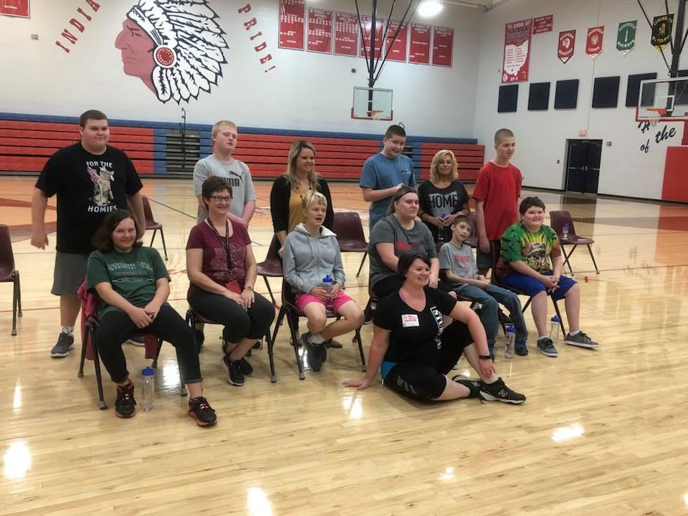  Transition Services The Individuals with Disabilities Education Improvement Act (IDEA) mandates transition services planning for students with disabilities who are 16 years of age. In Ohio, schools must begin transition planning when the student turns 14. Transition services are systematic, purposeful, actions to prepare and support students in their transition from the school community to adult community living. Services often include direction in the areas of personal and social skills, daily living skills, and occupational and vocational skills. The transition plan is specifically stated in the child's Individualized Education Program (IEP).  The Adams County Transition Team meets once a month during the school year and is made up of all service agencies and local school districts. The Adams CBDD serves as the Transition Team Coordinator.

